Sales Data Analysis Report

**Insightful Analysis**

* Top Performing Products:

Paseo and VTT are the most profitable products, with the majority of sales originating from the Government segment.

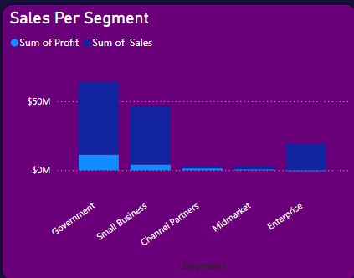

* Profit Goals Achievement:

USA is the only country that is close to target profit goal, with Germany following as the second-best performer.

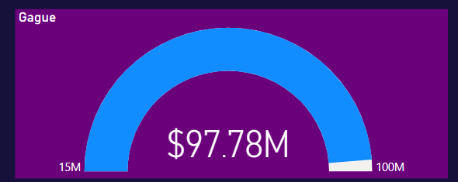

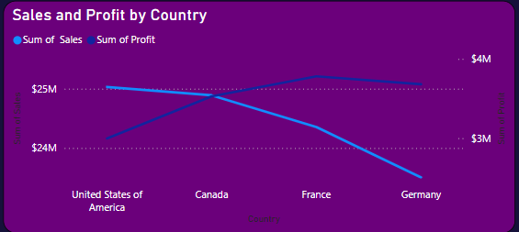

* Government Segment in US Region:

Within the Government segment of the US region, the most profit-bringing products are Paseo and VTT.

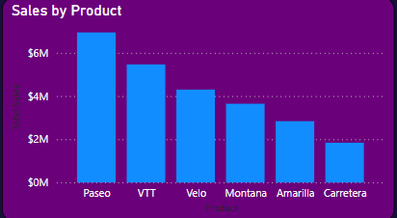

* Sales Trends:

There has been a general reduction in sales from October of the previous year to August this year.

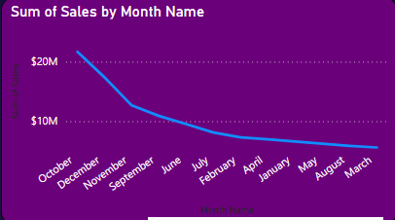

* Country-Specific Sales and Profit Trends:

Line charts indicate that, except for US and Mexico, all other countries have experienced a drop in sales and profit margins.

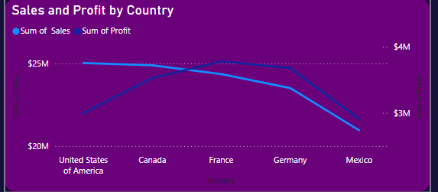

**Additional Insights**

* Sales Concentration:

A significant portion of the overall sales is concentrated in a few key products and segments, indicating potential areas for targeted marketing and sales strategies.

* Seasonal Sales Impact:

The reduction in sales observed from October to August suggests possible seasonal factors affecting demand, which could be important for inventory and promotional planning.

* Regional Variations:

The varying performance across different regions highlights the need for region-specific strategies, especially in underperforming areas.